[CODE]

Programming the Gameplay Inventory :

**For Alejandro , Aws , Sara .**

***INVENTORY :***

Example :

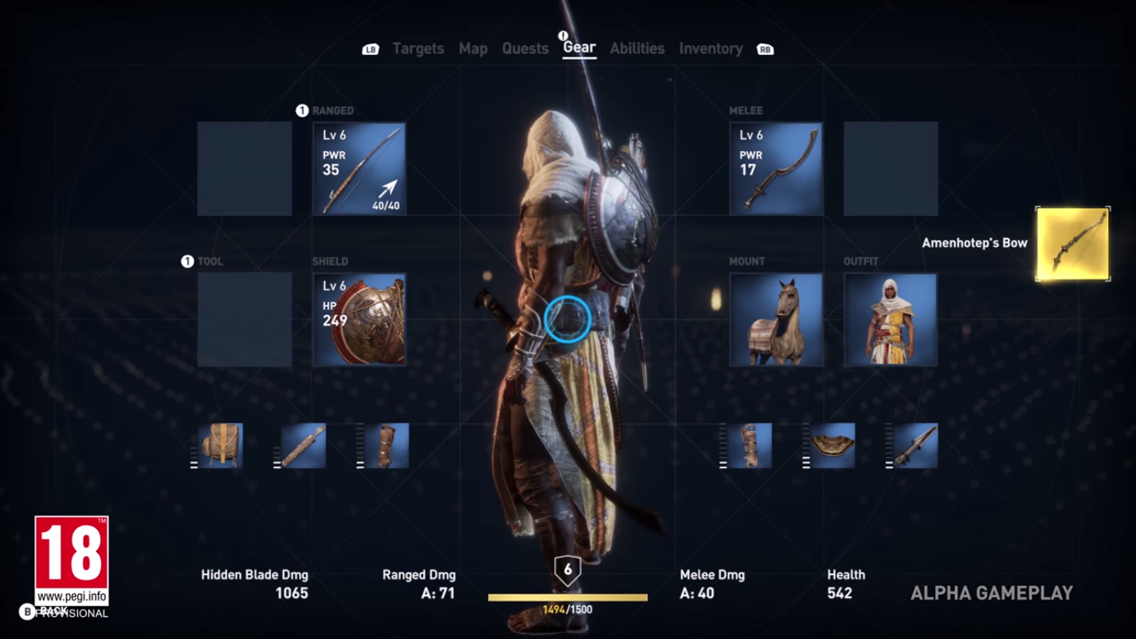( captures from here : link ! : <https://www.youtube.com/watch?v=OzHpcyqP_LE&feature=youtu.be&t=2m52s>

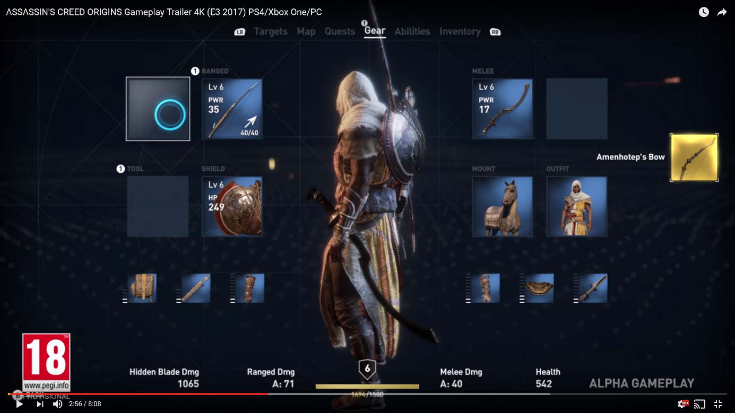

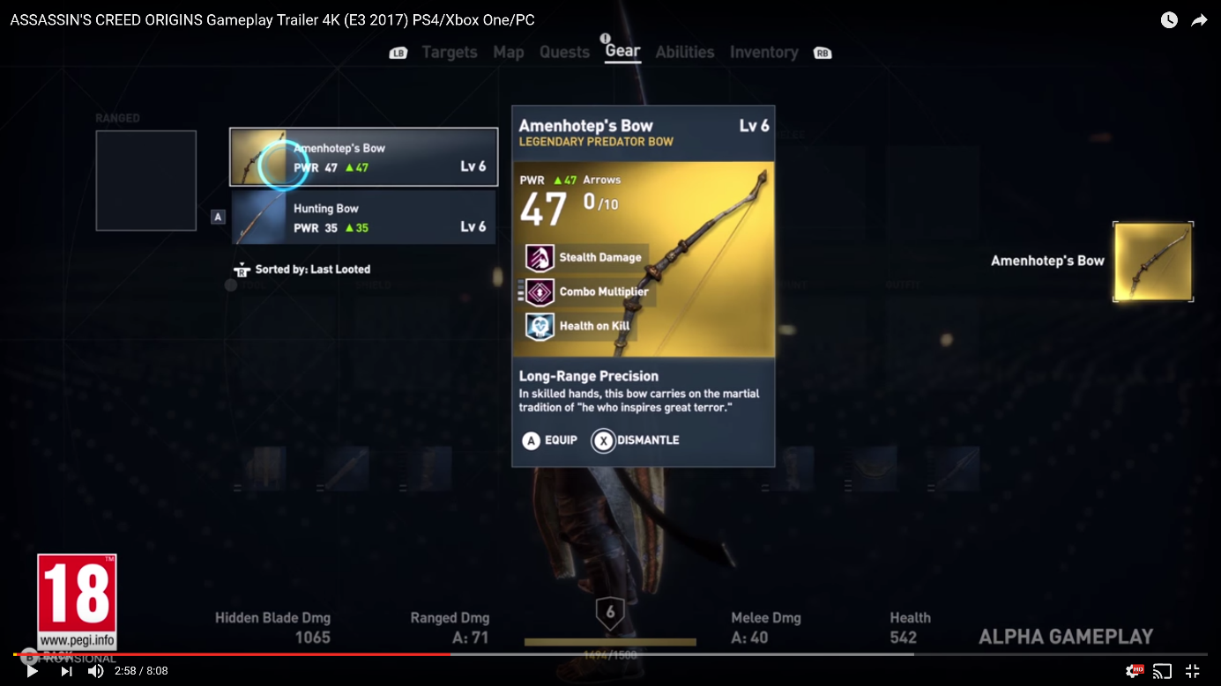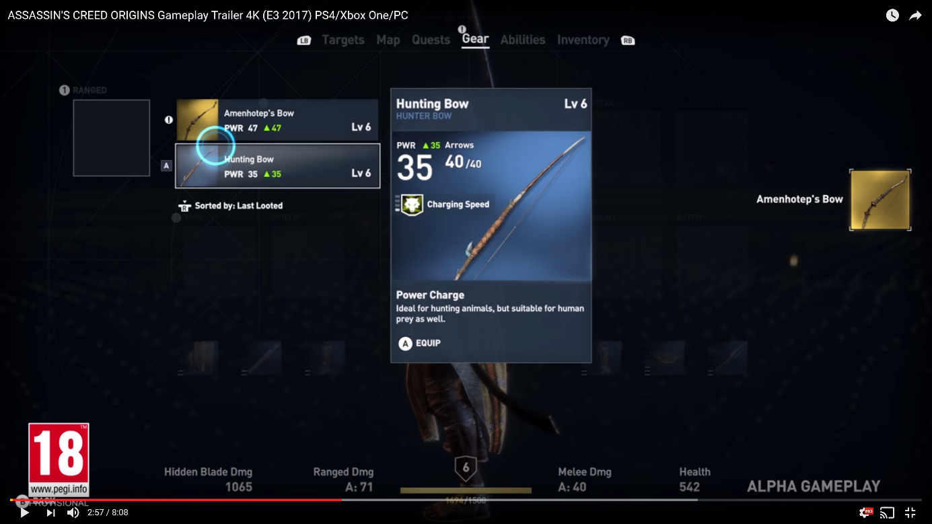

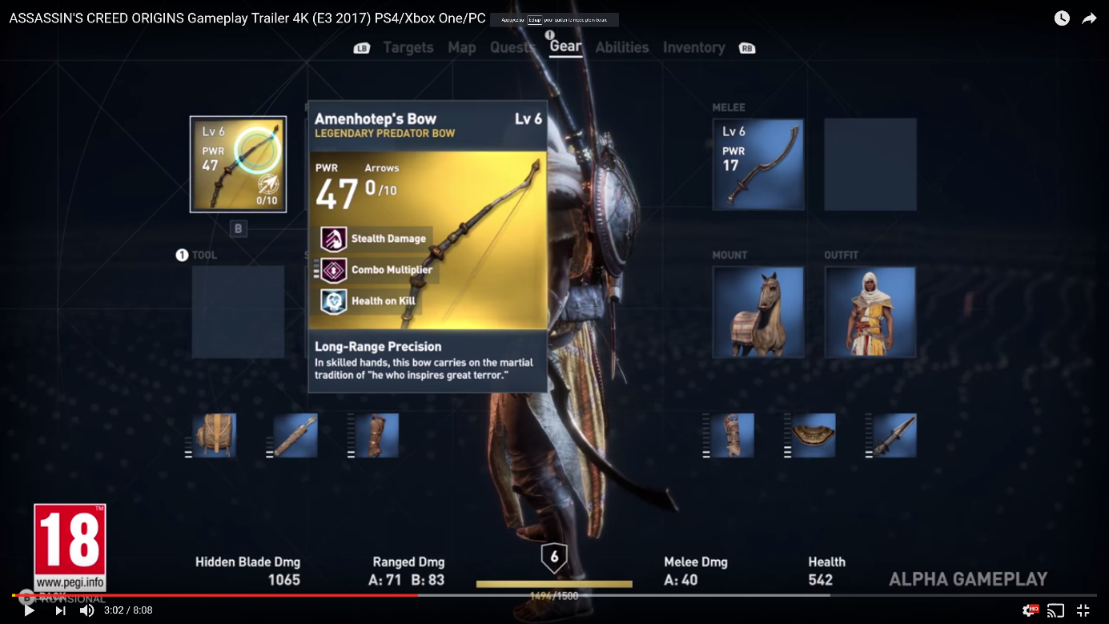

[CODE]

Programming the Gameplay Character Controller :

For Aws,

***Character Conroller :***





***Links : Animations On Slack , or Github Repertory . provided incrementally , if possibles and needed : talked and discussed about the animations if they are goods or nots ☺***

***NPC :***

CODE]

Programming the Gameplay Character Cameraaaaas :

***FPS :***

***TPS :***

